Experiment Name: Building Computer Network using Router in Cisco Packet Tracer.

Introduction
In modern communication systems, routers play a vital role in connecting multiple networks and directing data packets to their correct destinations. Cisco Packet Tracer is a widely used simulation tool that allows students to design, configure, and test networks in a virtual environment without physical hardware. In this lab, a network topology is created and configured using a router to enable communication between different devices and networks. This practical activity helps in understanding routing concepts, IP addressing, and verifying connectivity in a simulated network setup.

Objectives
The main objectives of this lab are:
- To understand the role and functionality of routers in a computer network.
- To design a basic network topology using Cisco Packet Tracer.
- To configure router interfaces with appropriate IP addressing.
- To establish communication between different network segments through proper routing configuration.
- To verify network connectivity using simulation tools like ping and traceroute commands.
- To enhance practical knowledge of networking concepts such as routing, IP addressing, and packet forwarding.

Procedures of the Experiment:
- Opening Cisco Packet Tracer Software:
Launch the application and open a new workspace.
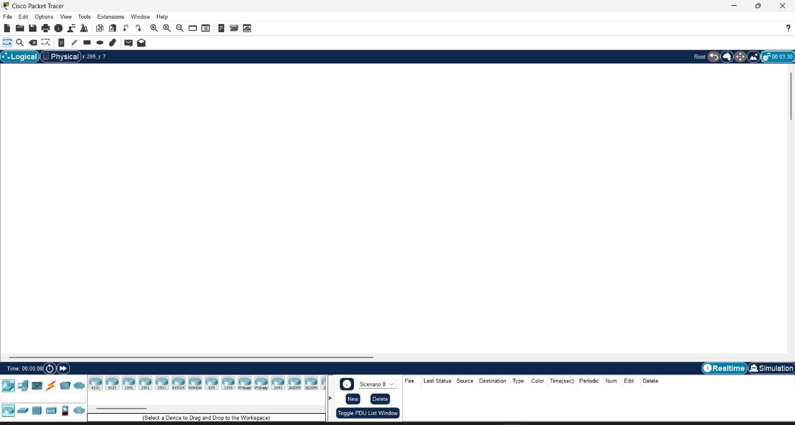
Figure 3.1: Opening The Software

- Adding Devices
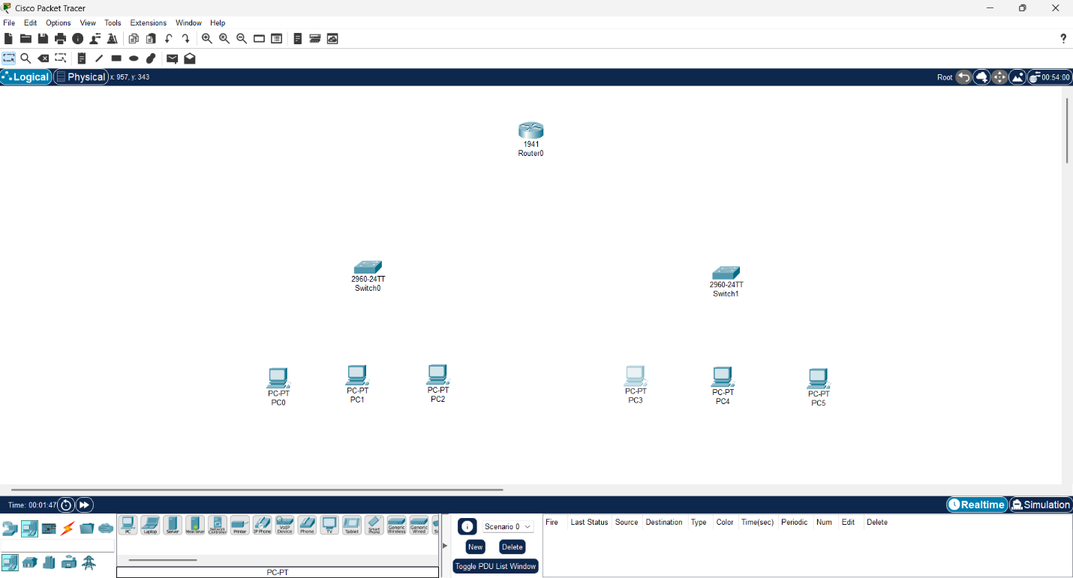
From The Devices Section of the Cisco Packet Tracer Software, drag and drop a router, two switches, and six PCs onto the workspace.
Figure 3.2: Adding devices

  - Connecting Devices
    - PC0, PC1 & PC2 → Switch0
    - PC3, PC4 & PC5 → Switch1
    - Switch0, Switch1 → Router1 (FastEthernet0/0, FastEthernet0/1)
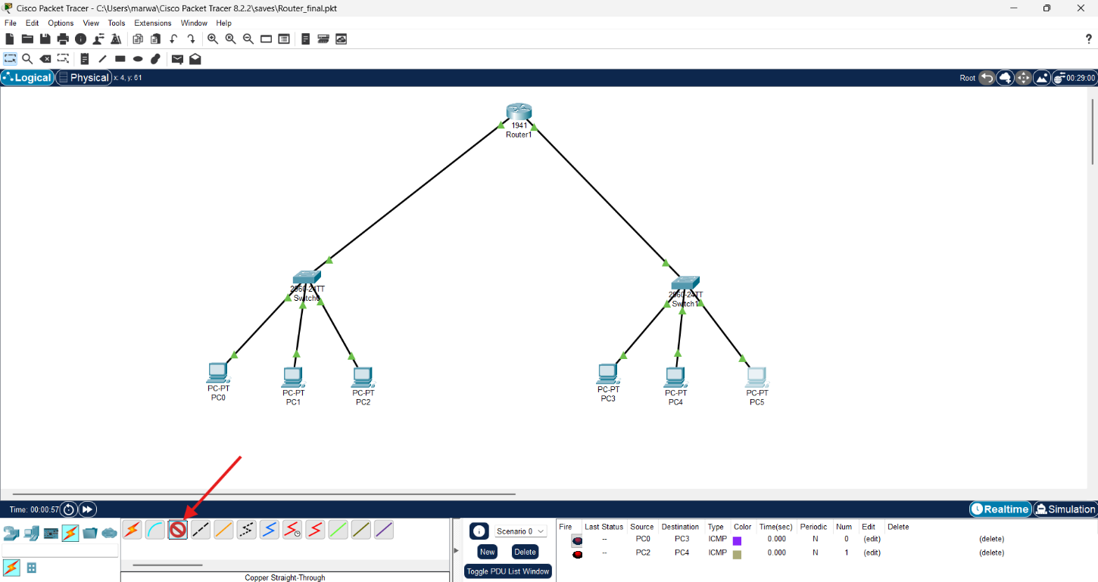
Figure 3.3: Connecting devices

  - Assigning IP Address to Devices: In order to assign IP Address to each device, we will go to the device setting by double clicking each device, then from config section we have to go to IP Configuration option. Later we will assign an IP Address to each of the devices.
  - Network 1:
    - PC0: 10.10.10.1 / 255.255.255.0
    - PC1: 10.10.10.2 / 255.255.255.0
    - PC2: 10.10.10.3 / 255.255.255.0
  - Network 2:
    - PC3: 192.168.0.1 / 255.255.255.0
    - PC4: 192.168.0.2 / 255.255.255.0
    - PC5: 192.168.0.3 / 255.255.255.0
  - Switch Interconnection:
    - Switch0: 10.10.10.4
    - Switch1: 192.168.0.4
Add These Two IP addresses in the Router also in the Gateway Section of the corresponding Connected PCs.
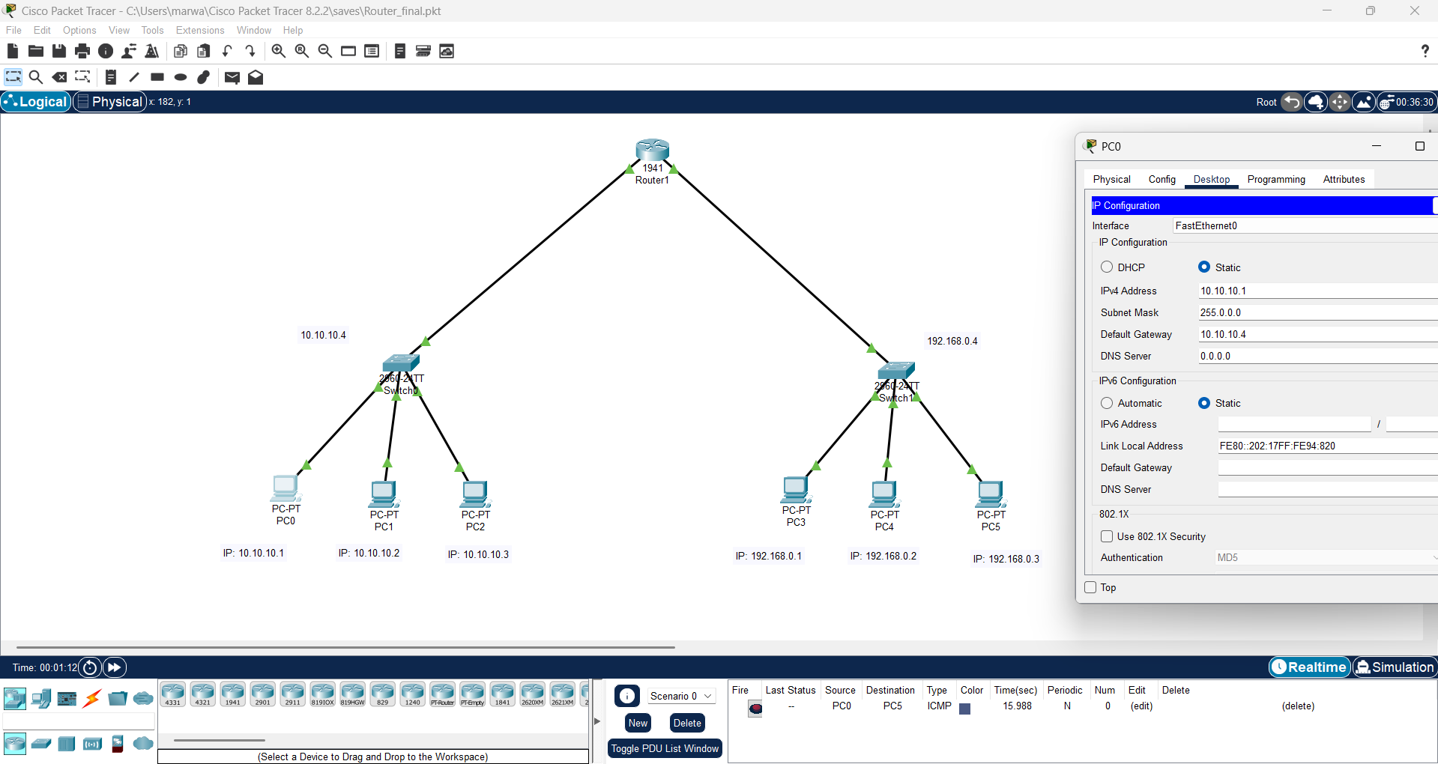
Figure 3.4: Assigning IP Address

- Testing Connectivity
The last step to validate the setup of networking devices, and to get the result of the whole setup we built using the Cisco Packet Tracer software we need to test The Connectivity of the devices, Hence, of the whole system by following the procedures described below. By sliding the ICMP packets (which is located at the end of the toolbar) from a pc connected with the first switch to a pc that is connected with the second Switch (for example: From the PC0→PC5) and then by running the simulation we can test the connectivity of the full setup. Here is the figure of the Successful Network setup.
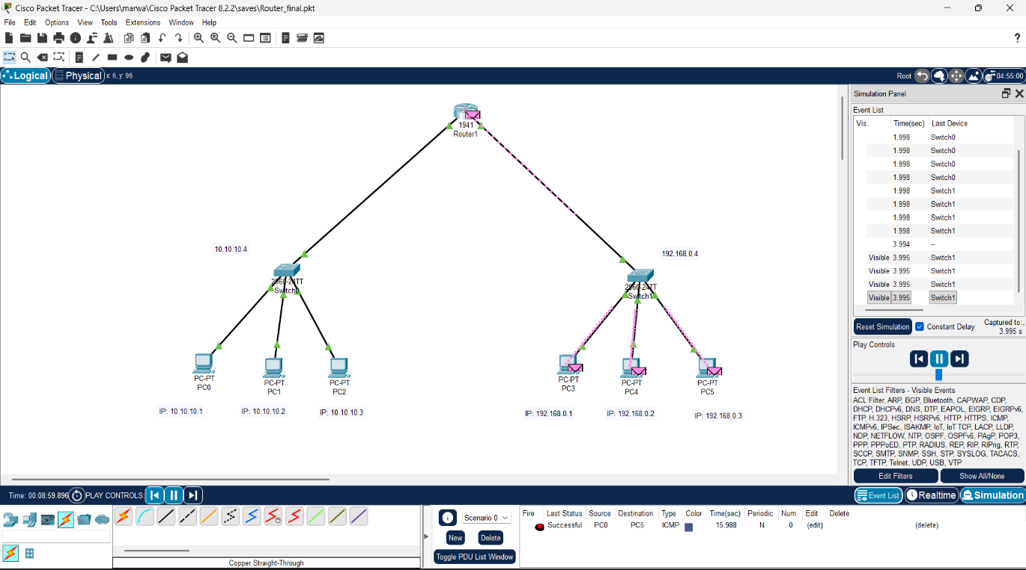
Figure 3.5: Testing Connectivity

Result of the Experiment
All PCs from both networks communicated successfully through the routers. Static routing enabled data exchange between the two networks.
Conclusion
This Lab Report demonstrated how routers connect multiple networks and route packets between them. The experiment confirmed that router is one of the most essential networking devices for inter-network communication.

